Orientation: position or positioning with relation to the points of the compass or other specific directions

Attitude is the orientation of the craft with respect to a set of reference axes. **Attitude** means the orientation of your aeroplanes relatives to the horizon, including Pitch (relative to Y-Axis), Roll (Relative to X-Axis, and Yaw (Relative to Z-Axis)

**Visual flight rules** (**VFR**) :

**Visual flight rules** (**VFR**) are a set of regulations under which a [pilot](https://en.wikipedia.org/wiki/Aviator) operates an [aircraft](https://en.wikipedia.org/wiki/Aircraft) in weather conditions generally clear enough to allow the pilot to see where the aircraft is going. Specifically, the weather must be better than basic VFR weather minima, i.e. in [visual meteorological conditions](https://en.wikipedia.org/wiki/Visual_meteorological_conditions) (VMC), as specified in the rules of the relevant aviation authority. The pilot must be able to operate the aircraft with visual reference to the ground.

In order to fly VFR Visual Meteorological Conditions (VMC) have to be maintained. Basically it means you cannot fly through clouds and need to keep a safe distance. In some types of airspace you also have to see the ground. As under VFR you are responsible for seeing other aircraft and avoid a collision there is also a minimum horizontal visibility.

**Instrument Flight Rules (IFR):**

Whenever VMC (see above) cannot be met a pilot with the proper skills, rating and an IFR equipped aircraft can still perform a flight. In theory flights can be performed with zero visibility from start to landing. That of course sounds quite scary and certainly puts the flight crew under a lot of stress - which is why larger aircraft for commercial service are not flown by a single pilot.

IFR is the way to go at night also when the country you want to fly in or through does not allow VFR at night

Unlike VFR flights IFR happens usually within controlled airspace and **requires filing a flight plan (usually) ahead of time.** **The routing is not completely at the pilot’s discretion (fee choice).** Established waypoints and airways have to be used and the altitude for the flight is determined by things like minimum airway altitude, minimum radar vectoring altitude (MRVA) and traffic situation.

**Attitude indicator (Artifical horizon):**

**This shows the aircraft relationship to the horizon.**

Attitude indicator is the gyro driven instrument. Attitude indicator in not important for VFR flight as we can see the outside world easily but is incredibly important for IFR flight. It shows pitch and bank information instantaneously and very accurately. Powered by D electric or AC electric by using an inverter but can also be vacuum or pressure driven. In glass cockpit, it is electronically driven.

Description:

They will have pitch references which is labelled or numbered. They will also have bank indications in 10 degree increments.

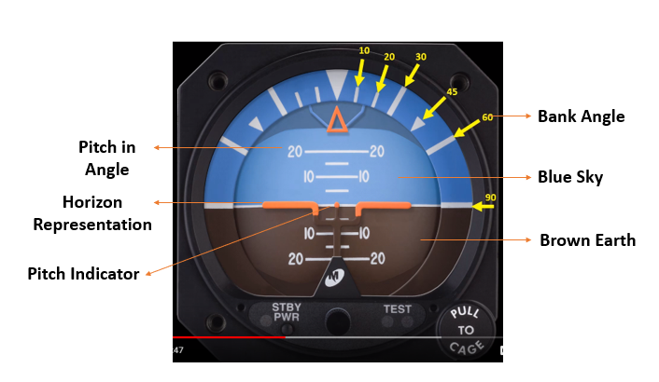

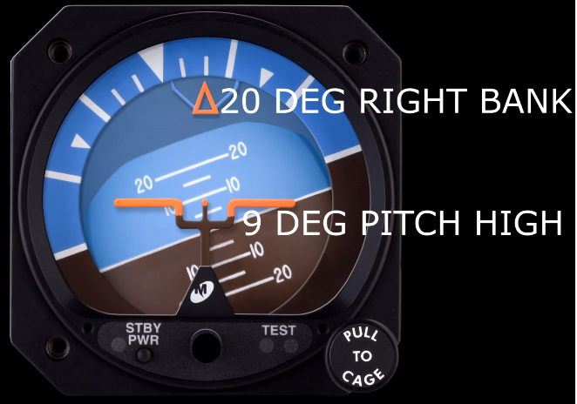

**Three Point Altimeter:**

There are 10 major indices numbered 0 to 9 and 4 minor indices in 1 major indices interval. Each minor indices interval is 20 feet and 1 major indices equals 100 feet.

A **Kollsman window** is small **window** in an aircraft altimeter used to calibrate the instrument and compensate for atmospheric pressure changes. **WE ADJUST THIS BEFORE EVERY FLIGHT.**

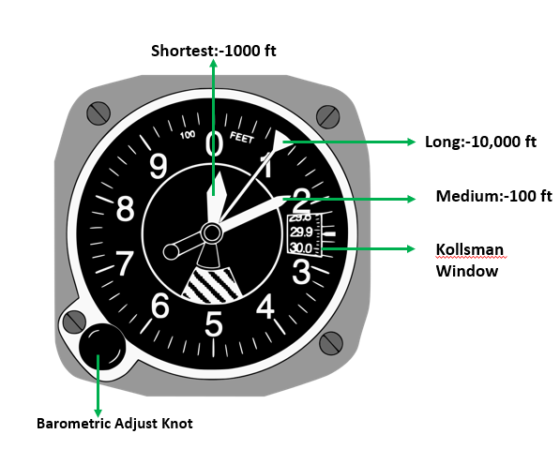

The 10,000-foot pointer (LONGEST) is equally to 1 and not yet up to the

2 and so it is read as:   **1 x 10,000 = 10,000 +**

The 1,000-foot (SMALLEST) pointer is past the 0 and not yet up to the

1 and so it is read as:    **0 x 1,000 = 0 +**

The 100-foot pointer (MEDIUM) is past 1 major indices past the 4 minor and so

Therefore, it is read as:  **1.8 x 100 = 180**

The indicated altitude is the sum of the pointers:   **10,180 feet**.

**Vertical Speed Indicator:**

It shows whether the aircraft is climbing, descending or in level flight.

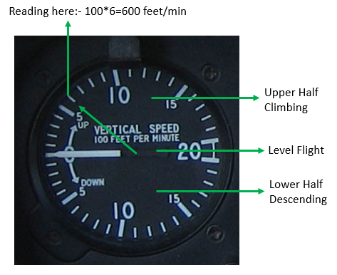

**Airspeed Indicator:**

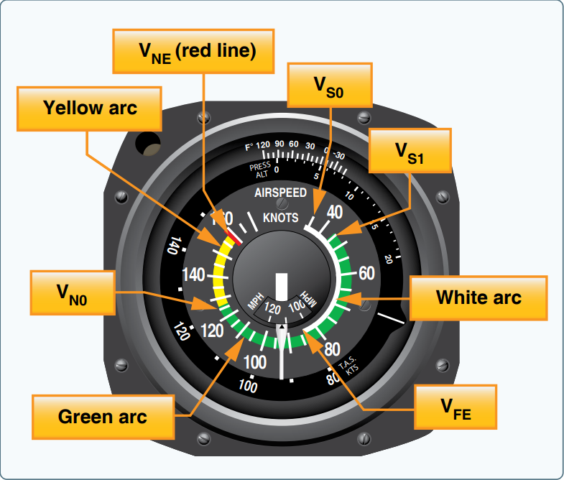

Vso= Stall speed (minimum speed with which it can maintain level flight) with flaps down (small angle only)

Vs1=Stall speed with flaps up as flaps up decreases lift so minimum speed increased to maintain level flight.

Vfe= When flaps are fully extended then the drag is more dominant so lift decreases and minimum speed increases to maintain level flight

Vno=Normal operating speed i.e. structural integrity is safe until now

Vne=Never exceeding speed i.e. after exceeding this speed then structural breakdown may occur.

**Heading Indicator (Directional Gyro):**

The **heading indicator** (also called an **HI**) is a [flight instrument](https://en.wikipedia.org/wiki/Flight_instrument) used in an [aircraft](https://en.wikipedia.org/wiki/Aircraft) to inform the [pilot](https://en.wikipedia.org/wiki/Aviator) of the aircraft's [heading](https://en.wikipedia.org/wiki/Aircraft_heading).

It may be powered by different sources like 24 V dc electric and 115 v ac using inverter. For training type, use vacuum system or pressure system.

Directional Gyro works independently of the earth’s magnetic field so it’s useful in north far and far south where the magnetic reference is unusable. So, another directional reference should be present to align the directional gyro from.

Directional Gyro must be set against magnetic reference as DG is not magnetic and has no direct reference to magnetic north.

DG is susceptible to error due to drift and it should be checked and reset every 15 minutes with magnetic compass. As during flight DG can change in 16 degree per hour.

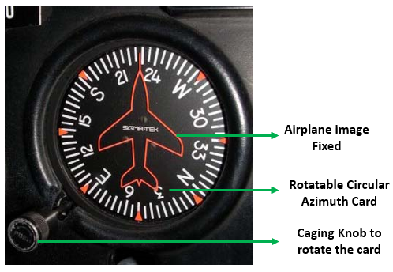

**Turn Cordinator:**

Turn coordinator works on the principle of precission. **Precession** is a change in the [orientation](https://en.wikipedia.org/wiki/Orientation_(geometry)) of the rotational axis of a [rotating](https://en.wikipedia.org/wiki/Rotation) body.

When the airplane banked to the right and if the airplane picture right wing tip touches the index R, then it takes 2 mins or 120 secs to make a complete turn or circle i.e. 3 degrees in a second. And 3 degree per sec is the standard rate turn.

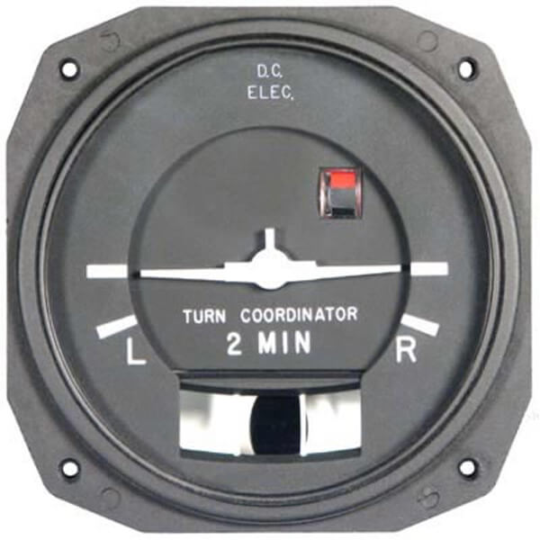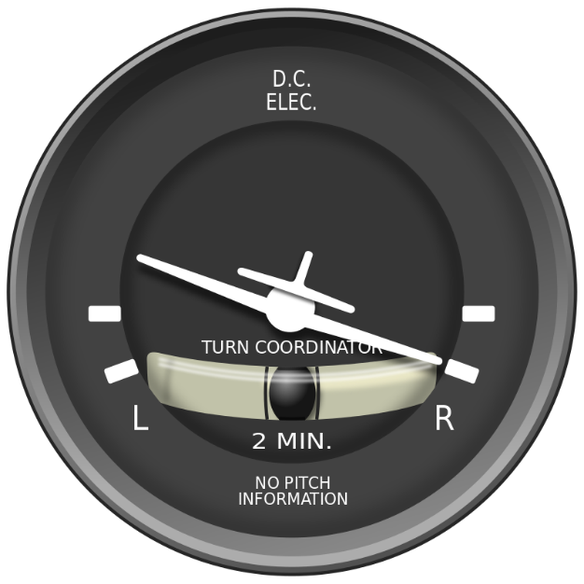

If during left turn, the ball also moves to the left then aircraft is slipping.

And if during left turn, ball moves to the right then aircraft is skidding.

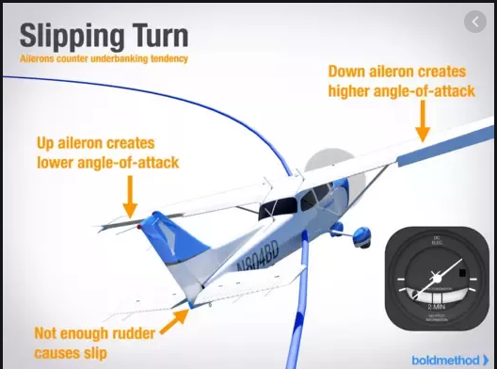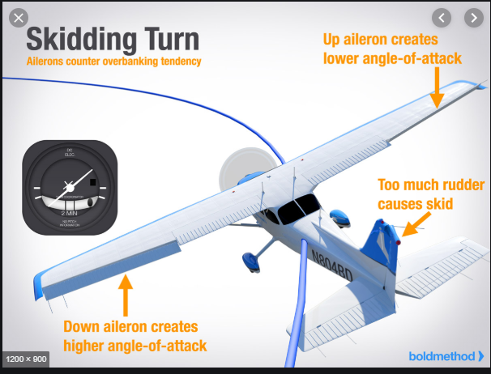

**Primary Flight Display:**

A Primary Flight Display or PFD, found in an aircraft equipped with an [Electronic Flight Instrument System](https://www.skybrary.aero/index.php/Electronic_Flight_Instrument_System), is the pilot's primary reference for flight information. The unit combines the information traditionally displayed on several electromechanical instruments onto a single electronic display reducing pilot workload and enhancing [Situational Awareness](https://www.skybrary.aero/index.php/Situational_Awareness).

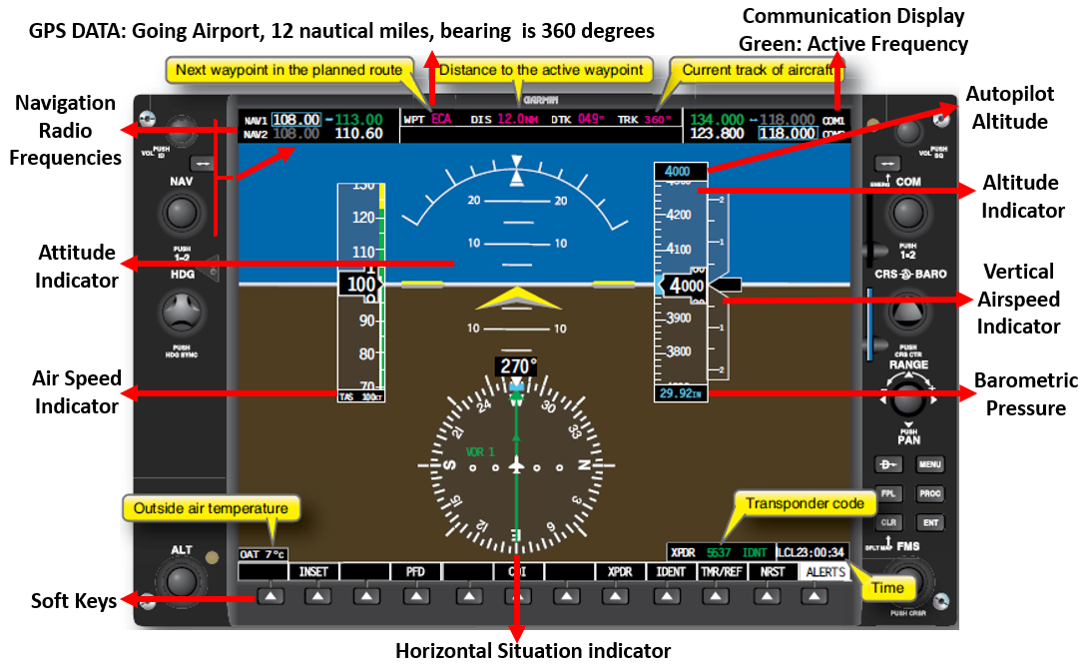

**Liquid Crystal:** <https://www.youtube.com/watch?v=iJks-gapzkk&t=66s>

When the solid is heated then it goes to intermediate state (which shows some properties of solid and some properties of liquid) and on further heating goes to liquid state. OR, which has properties in between true crystalline solid and true clear liquid.

Properties like solid:

* Orderly arrangements of particles
* Optical activity

Properties like liquid:

* Viscosity
* Surface tension
* Fluidly (in a way that flows easily)

**Driver Circuit:**

In electronics, a **driver** is a **circuit** or component used to control another **circuit** or component, such as a high-power transistor, liquid crystal display (LCD), and numerous others.

**Machmeter:**

A **Machmeter** is an [aircraft](https://en.wikipedia.org/wiki/Aircraft) [pitot-static system](https://en.wikipedia.org/wiki/Pitot-static_system) [flight instrument](https://en.wikipedia.org/wiki/Flight_instrument) that shows the [ratio](https://en.wikipedia.org/wiki/Ratio) of the [true airspeed](https://en.wikipedia.org/wiki/True_airspeed) to the [speed of sound](https://en.wikipedia.org/wiki/Speed_of_sound), a [dimensionless quantity](https://en.wikipedia.org/wiki/Dimensionless_quantity) called [Mach number](https://en.wikipedia.org/wiki/Mach_number). This is shown on a Machmeter as a [decimal fraction](https://en.wikipedia.org/wiki/Decimal_fraction). An aircraft flying at the speed of sound is flying at a Mach number of one, expressed as *Mach 1*.

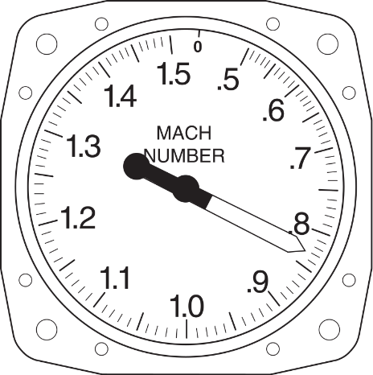

Machmeter reading a [Mach number](https://en.wikipedia.org/wiki/Mach_number) of 0.83

In [aviation](https://en.wikipedia.org/wiki/Aviation), **LNAV** (short for **lateral navigation**; usually pronounced *el-nav*) is [azimuth](https://en.wikipedia.org/wiki/Azimuth) navigation without vertical guidance

.

Bearing

A bearing is a direction. Bearings are measured clockwise from north, so north is zero degrees, east is 90 degrees, south is 180 degrees, and west is 270 degrees.

A bearing is the direction from one spot to another, measured in **degrees**, from the reference line of north; in other words it's one of the 360 **degrees** of the **compass** rose.

Navigation Display:

The programmed waypoints are displayed in the circle as green stars. On top right, ground speed and true air speed is given. Under this is the wind, first in degrees and on the right is the strength in knots.

Range of distance can be changed according to need.

Airports, VOR etc can be shown in the display range.

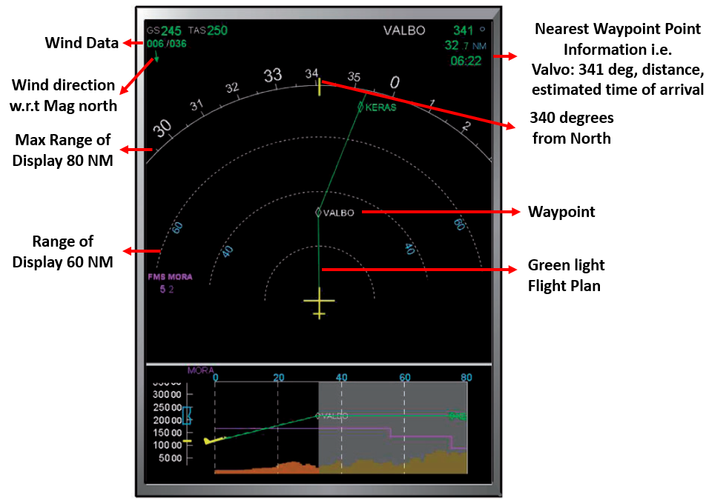

**Engine Warning Display:**

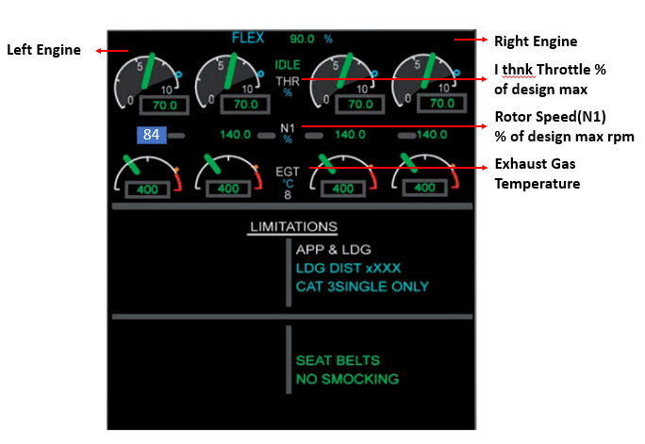

**True North**  
  
Each day the Earth rotates **about its axis once**. The **ends of the axes** are the True North and South poles.

**Magnetic North**  
  
A compass needle points to the **magnetic north pole**. The magnetic north pole is currently located in the Baffin Island region of Canada, and **from the UK, is west of true north.** The horizontal angular difference between True North and Magnetic North is called MAGNETIC VARIATION or DECLINATION.

Radio Beacon:

In [navigation](https://en.wikipedia.org/wiki/Navigation), a **radio beacon** (rarely **electromagnetic beacon**) is a kind of [beacon](https://en.wikipedia.org/wiki/Beacon), a device that marks a fixed location and allows [direction-finding](https://en.wikipedia.org/wiki/Direction_finding) equipment to find relative [bearing](https://en.wikipedia.org/wiki/Bearing_(navigation)). Radio beacons transmit a [radio signal](https://en.wikipedia.org/wiki/Radio_signal) that is picked up by radio direction-finding systems on ships, aircraft and vehicles to determine the direction to the beacon.

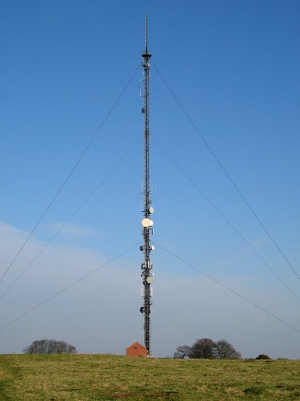

The remaining tower on Borough Hill in the UK is used as a radio beacon for aircraft navigation.

**NAVAIDs**

Navigational Aids (NAVAIDs) are physical devices on the ground that aircraft can detect and fly to. There are many different kinds of NAVAIDs, such as Very High Frequency (VHF) Omnidirectional Range / Distance Measuring Equipment (VOR/DME) and the Instrument Landing System (ILS), which is made up of the Glideslope (GS) and the Localizer (LOC). VOR facilities allow the pilot to follow a designated flight path by using the aircraft’s cockpit gauges to indicate their positions. ILS transmits guidance beams to allow the pilot to land safely and efficiently.

**VHF Omni-Directional Range (VOR):** <https://www.youtube.com/watch?v=iCCk2ch-xL4>

**Very High Frequency** (**VHF**) **Omni-Directional Range** (**VOR**) is a type of short-range [radio navigation](https://en.wikipedia.org/wiki/Radio_navigation) system for [aircraft](https://en.wikipedia.org/wiki/Aircraft), enabling aircraft with a receiving unit to determine its position and stay on course by receiving radio signals transmitted by a network of fixed ground [radio beacons](https://en.wikipedia.org/wiki/Radio_transmitter). It uses frequencies in the [very high frequency](https://en.wikipedia.org/wiki/Very_high_frequency) (VHF) band from 108.00 to 117.95 [MHz](https://en.wikipedia.org/wiki/MHz). Developed in the [United States](https://en.wikipedia.org/wiki/United_States) beginning in 1937 and deployed by 1946, VOR is the standard air navigational system in the world,[[2]](https://en.wikipedia.org/wiki/VHF_omnidirectional_range#cite_note-Kispo-2)[[3]](https://en.wikipedia.org/wiki/VHF_omnidirectional_range#cite_note-3) used by both commercial and general aviation. In the year 2000 there were about 3,000 VOR stations operating around.

VOR is a radio station that transmits radio navigation signals in the very high frequency or VHF band. The station transmits radio signals called radials in every direction away from the station. Pilots use 360 radials and one for each degree in a circle to determine position. If the equipment in the airplane says the airplane is on the 360 degree radial then the airplane is north of the VOR (a)

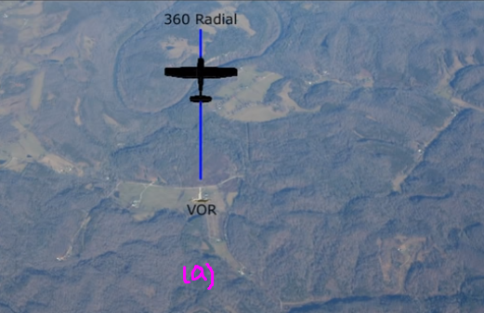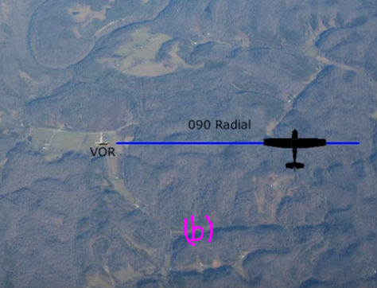

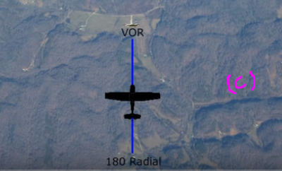

An airplane on the 90 radial means the airplane is at east of the VOR (b) and while 180 degree radial is due south of the station (c).

Since, pilots rely on the compass for directional guidance, the radials transmitted by VOR are aligned with magnetic north.

Before using VOR for navigation, it must be tuned and identified. Each VOR has its own frequency and Morse code identifier. Dial the VOR frequency into your navigation receiver and identify the navaid (**navigational aid** (**navaid**), is any sort of marker which aids the traveler in [navigation](https://en.wikipedia.org/wiki/Navigation), usually nautical or aviation travel) by listening to the audible morse code identifier. Means VOR frequency entered and identify that VOR by listening to its morse code identifier broadcast by the VOR station.

Each VOR has a three letter identifier, by hearing a Morse code for his three letter identifier you can positively identify or guarantee that the signal on your display is being received from the intended VOR.

To find the location from VOR, turn the **Omni-bearing selector knob (OBS knob)** on the VOR receiver display until the needle centers and **To-From flag indicates** **From**.

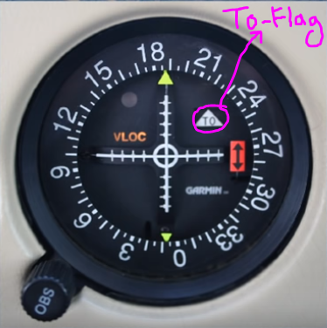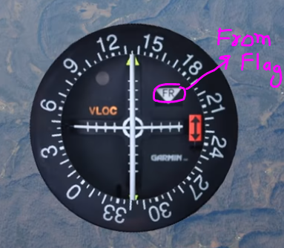

Once the needle is centered, your magnetic bearing or radial from the VOR is shown on the top of the display. Here, the reading if approximate 135 degree. This tells you the airplane is located over 135 radial i.e. airplane is South East to the VOR.

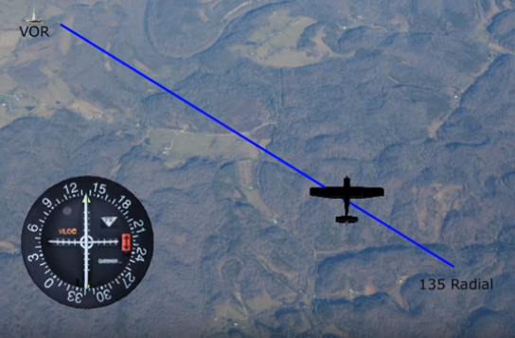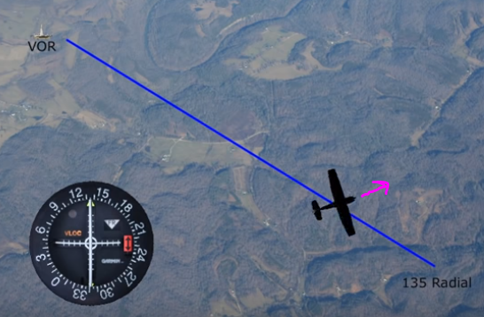

**One confusing thing here is that the radial of airplane has nothing to do with your heading. Means which direction it is headed just only location relative to VOR as shown above.**

**TO FIND THE DIRECTION TO A VOR**, rotate the OBS (i.e. outer numbering thing) until the needle is centered with a **To** indication. The number shown on the top of display is the bearing from your airplane to the VOR. Your bearing of the airplane from the station is also shown on the bottom of the display. Since, the VOR is displaying the direction to the station and your airplane is flying that heading so you will be heading directly to the VOR.

The white long needle is called the **Course Deviation indicator**

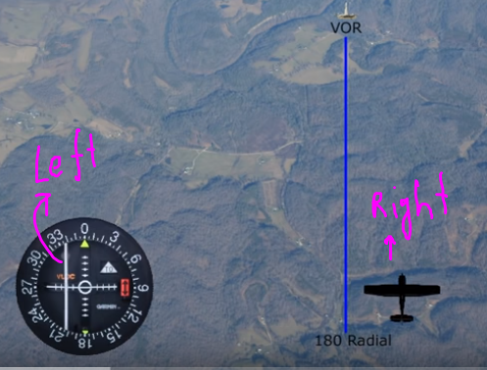

**Distance Measuring Equipment (DME):** <http://slideplayer.com/slide/9749267/>

DME consists of stations on the ground and equipment in the airplane.

DME operates in the UHF band of frequencies. When VOR is fitted with DME equipment it is referred to as VOR/DME. Each VHF VOR frequency is paired with a specific UHF DME frequency. This means the pilot only need to use the VOR frequency and doesn’t need to be concerned with the DME UHF frequency.

Before using DME, identify the DME to be used by listening for its Morse code identifier. DME equipment does not have its own unique identifier like VOR but instead DME uses the identifier of the VOR to which it is attached. The DME will transmit its parent VORs Morse code identifier once every 30 seconds.

DME operates by measuring the time it takes for a radio signal to be relayed from the airplane to the ground based DME equipment and back. The result is displayed in nautical miles to the pilot.

* DME is a type of en-route navigation system for aircraft.
* DME often installed near VOR stations so as to provide combined bearing (given by VOR) and distance (given by DME).
* When DME is installed with the VOR, it is referred to as a VOR/DME.

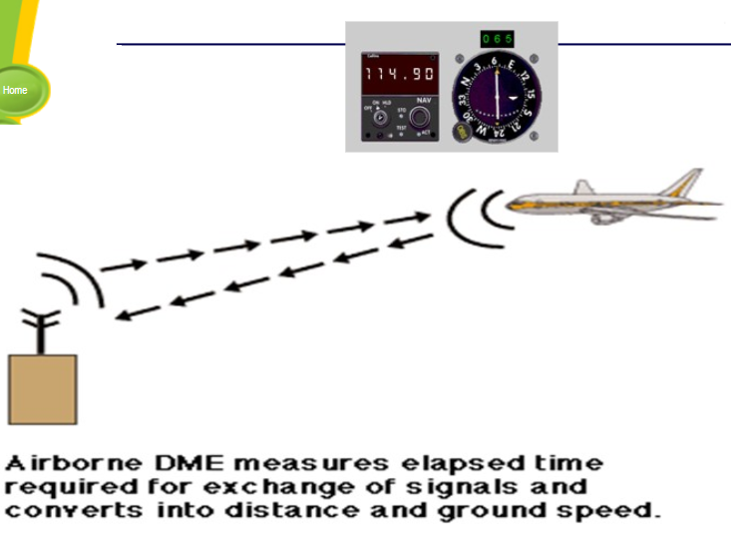

* DME provides the physical distance from the aircraft to the ground DME transponder expressed in Nautical Miles (NM).
* DME also calculates ground speed and the time needed to reach the station **if the aircraft is fitted with appropriate computer.**

DME consists of three basic components.

* DME antenna on the aircraft body.
* DME navigation display unit in aircraft cockpit.
* DME transmitter/receiver in the ground.

**Advantages of DME**

DME is extremely accurate: Provide continuous and accurate indication of the slant range distance.

Aircraft Handling Capability: The transponder equipment should be capable of handling 100 to 200 aircrafts.

Large coverage: DME facility provides coverage up to 200 NM.

**Disadvantages of DME**

**As VOR the DME** is also restricted to **line-of-sight transmission**. For example, the aircraft at altitude below 10’000 ft is unable to detect the DME signal.

The exploitation of **intelligent knowledge based systems (IKBS)** technology, frequently

referred to as ‘expert systems’, to assist the pilot in carrying out the mission

is the subject of a number of very active research programmes, particularly in the

United States. One of the US programmes is the ‘pilot’s associate program’ which

aims to aid the pilot of a single seat fighter/attack aircraft in a similar way to the

way in which the second crew member of a two crew aircraft assists the pilot. The

prime aim is to reduce the pilot work load in high work load situations.

next generation of military aircraft as these will

use a single pilot to carry out the tasks which up to now have required a pilot and a

navigator/weapons systems officer.

Out of the many proposed expert system on an aircraft, intelligent displays management system is a subset of all the proposed expert system to manage and present the required information to a pilot in high work load situation